**Wireless Adapter Configuration in XP**

**Windows XP/2000 built-in Wireless Configuration Tool**

The XP built-in configuration tool is not installed by default in Windows XP/2000, some additional patches might need to be installed depending on system patch level.

For **Windows XP**, install either [Windows XP Service Pack 3](http://www.microsoft.com/downloads/en/details.aspx?FamilyId=5B33B5A8-5E76-401F-BE08-1E1555D4F3D4&displaylang=en) or [Windows XP Service Pack 2](http://www.microsoft.com/downloads/en/details.aspx?FamilyId=049C9DBE-3B8E-4F30-8245-9E368D3CDB5A&displaylang=en) and [WPA2/WPS IE Update](http://support.microsoft.com/?id=893357). If you still use Windows XP Service Pack 1 somehow, please install this [Wireless Update Rollup Package](http://support.microsoft.com/?id=826942).

**Installing Wireless Adapter Driver and Configuring TCP/IP**

Please [check here to install wireless adapter driver and configure TCP/IP](http://www.home-network-help.com/configure-computer.html). This process is the same as you configure Ethernet network adapter.

**Note**: If you have enabled DHCP setting on the wireless router, then you should select **Obtain an IP address automatically** and **Obtain DNS server address automatically** on your wireless adapter’s TCP/IP setting.

**Configuring Wireless Adapter Properties.**

Before you start to configure wireless network adapter properties, you need to make sure [wireless zero configuration service](http://www.home-network-help.com/wireless-zero-configuration.html) is running and it’s supported by wireless adapter.

1) Go to **Start** and click on **Control Panel**.

2) Control Panel window will appear. Double click on **Network Connections**.

3) Network Connections window will appear. Right click correct **Wireless Network Connection** by identifying correct wireless adapter and click **Properties**.

4) Wireless Network Connection Properties will appear. Click **Wireless Networks** tab.

5) Tick **Use Windows to configure my wireless network settings**. This will change the wireless adapter management from wireless adapter configuration software to Windows XP built-in wireless configuration tool. Click **Add** to create preferred wireless network.

**Note**: Adding preferred networks will detect and join the added wireless network automatically if available when you restart your computer next time.

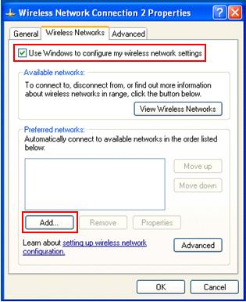

6) Wireless Network Properties window will appear. Here is the place you key in your wireless network information, it must match with the settings you set on wireless router. If not, you will fail to join the network.

Please key in **SSID** of your wireless network. SSID is the network name of this wireless network and must be identical for all devices in the network.

Choose network authentication if it’s enabled in your wireless router. Here are supported network authentications:

**Open** – If you want to use this option, I recommend you to use it with wired equivalent privacy (WEP) encryption key that shared among computers on wireless network. All network traffic is encrypted. If you do not enabled WEP with Open option, then everybody can join this wireless network without authentication and it’s not recommended.

**Shared** – You can use this option with WEP encryption key, however according to Microsoft, the traffic is not encrypted. Too bad and not recommended to use.

**WPA** – WiFi Protected Access (WPA) authentication with RADIUS server. This authentication is usually found in business networks.

**WPA-PSK** – WPA authentication with pre-shared key. AES or TKIP encryption is provided. Mostly used by home wireless users.

**WPA2** – WPA2 authentication with RADIUS server. This authentication is usually found in business networks.

**WPA2-PSK** – WPA2 authentication with pre-shared key. AES or TKIP encryption is provided. Mostly used by home wireless users.

For my setup, I will key in home-network as SSID, enable WPA2-PSK authentication with AES encryption and key in network key as last.

**Note**: If the network that you are adding provides a network key automatically, make sure that **The key is provided for me automatically** check box is ticked. This option is only available if you choose **Open** or **Shared** authentication.

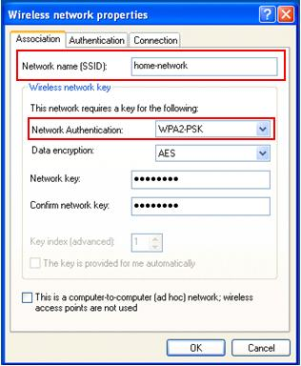

After keying wireless network information, click **Connection** tab, and tick **Connect when this network is in range**. The computer should be able to connect to wireless network when it’s in range.

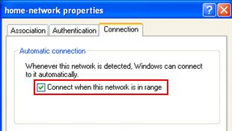

You can create several networks and arrange the preferred network as according to your wish.

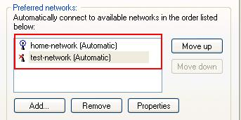

**Manual Connecting to An Available Wireless Network**

If you don’t wish to set preferred wireless network, click here to learn [manual connecting to an available wireless network](http://www.home-network-help.com/connect-to-wireless-network.html).

**Note**: Default XP wireless zero configuration will have difficulty to detect and join non-broadcast (hidden SSID) wireless network. You can enable SSID broadcast on wireless router to fix this issue.